Given the root of a binary tree, return *the postorder traversal of its nodes' values*.

**Example 1:**

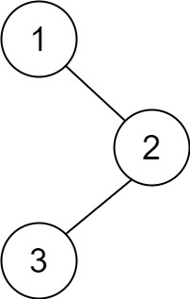

**Input:** root = [1,null,2,3]

**Output:** [3,2,1]

**Example 2:**

**Input:** root = []

**Output:** []

**Example 3:**

**Input:** root = [1]

**Output:** [1]

**Constraints:**

* The number of the nodes in the tree is in the range [0, 100].
* -100 <= Node.val <= 100

**Follow up:** Recursive solution is trivial, could you do it iteratively?